EXERCISE NO: 1
DATE:24.10.2020
AIM:
To print the calendar of given month and year, month must be in digit format, year in four digit format and if the given month and year are not in the specified format print “Invalid Input”.

PROGRAM:
import calendar
y = int(input())
m = int(input())
if (m > 0 and m <= 12) and (y>=1000 and y<=9999):
print(calendar.month(y, m))
else:
print("Invalid Input")

LINK:
http://103.53.53.18/mod/vpl/forms/submissionview.php?id=229&userid=1757

OUTPUT:
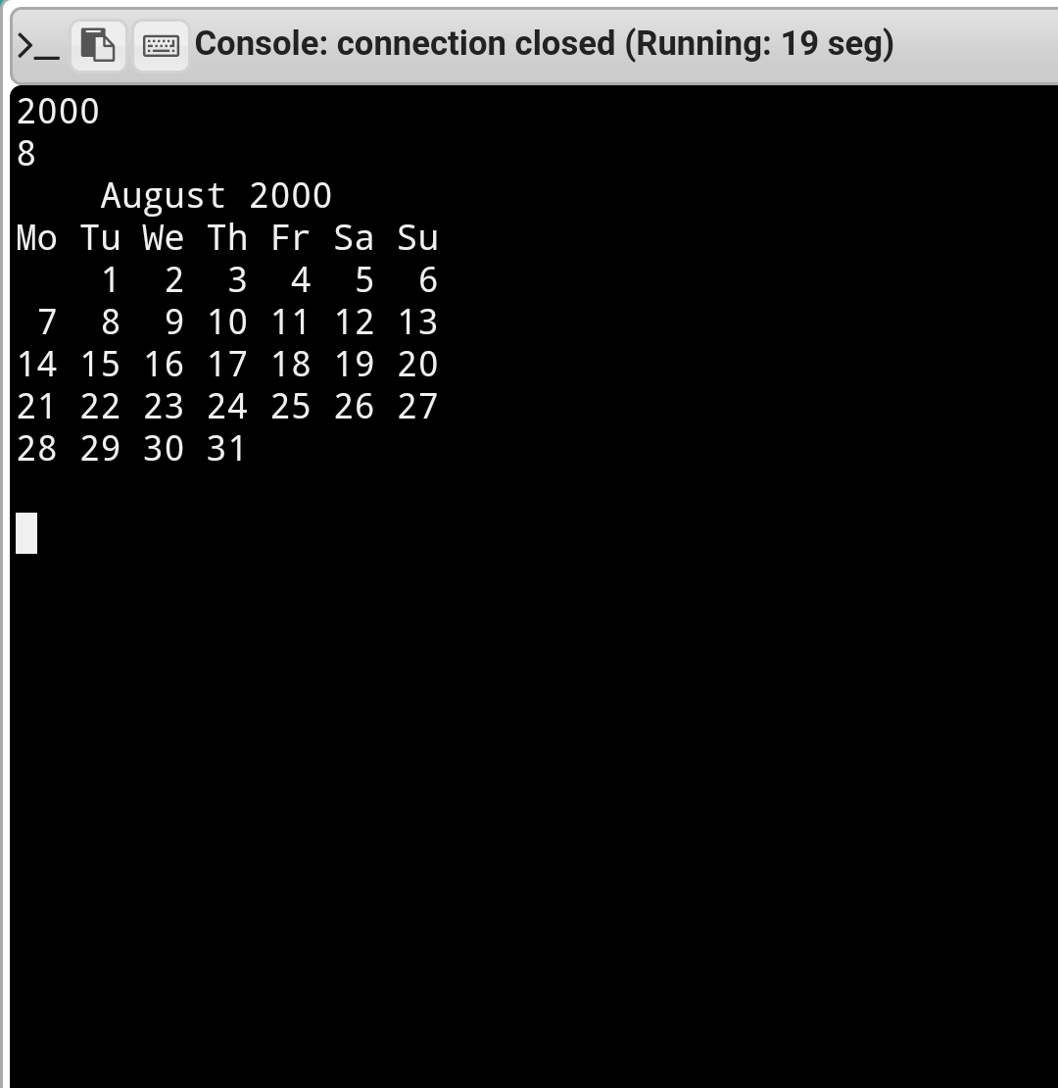

OUTPUT:
The calender for specified month and year is displayed.

